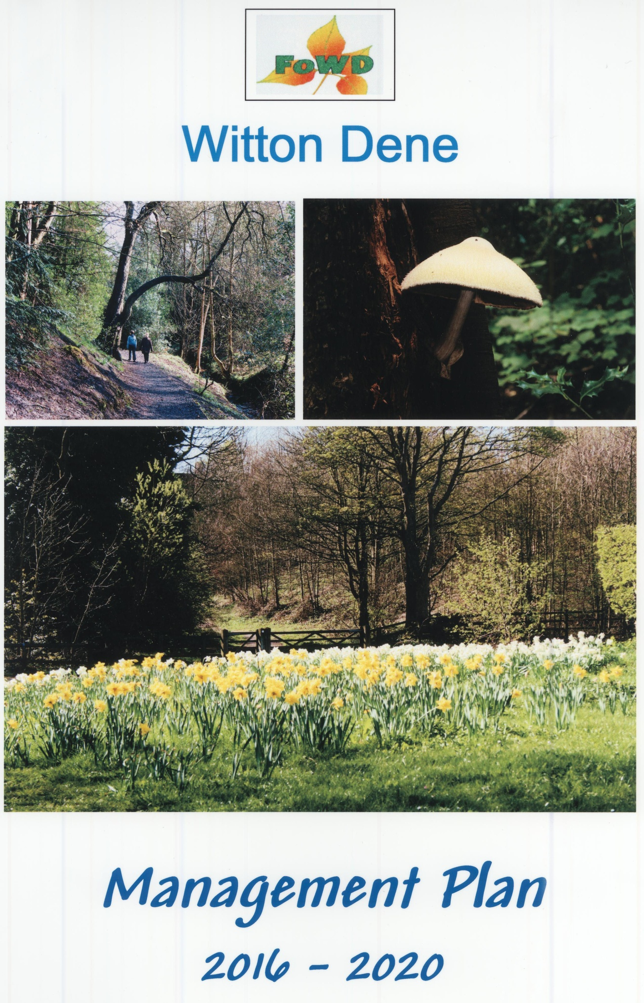
Witton Dene Local Nature Reserve
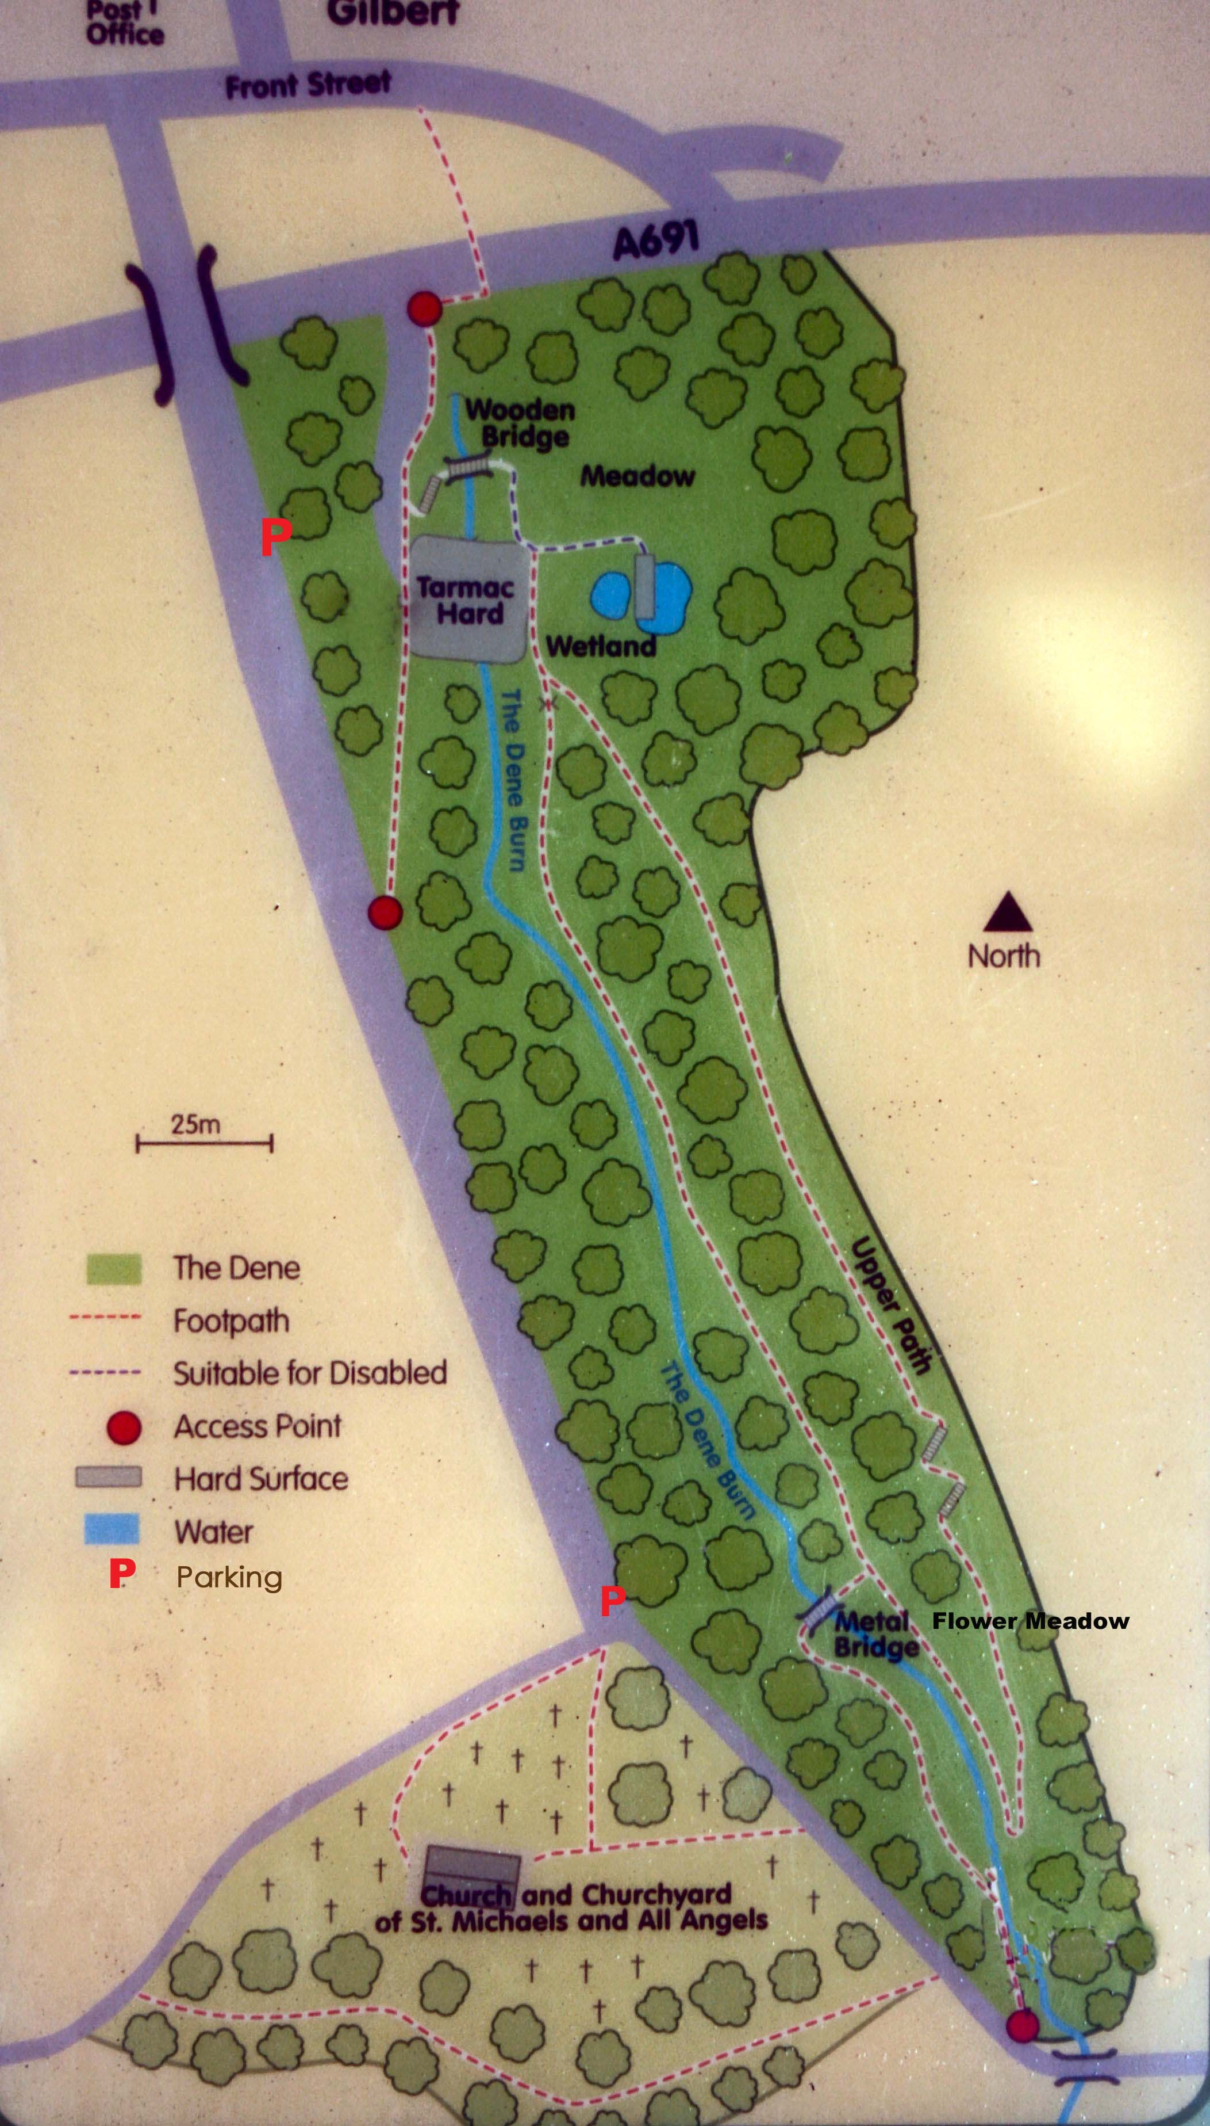
Durham County Council

1:1 LOCATION
Grid Ref NZ 234 454
Ordnance Survey Explorer 308
Postcode for GPS purposes DH7 6SU
Approx 3 miles from Durham City Centre

1:2 ACCESS AND VISITOR FACILITIES
There are two parking areas (see key Map above) once entering Coach Lane from B6312.These parking areas provide immediate access to the entrances to Witton Dene. The first one is adjacent to the parking layby and consists of a kissing gate which leads down a ramp into the north end of the Dene. The second parking area is at the end of Coach Lane which is the parking area used for access to St Michael and All Angels Church. This leads down a slope adjacent to churchyard at the bottom of which is an open gated entrance to the south of the Dene. A further gated entrance is available for walkers crossing the busy Bypass from Witton Gilbert Village.
A circular walk enables the visitor to take in most of the Dene. The lower path follows the course of the Dene Burn southwards. An upper path branches up from a Pond at the north end and re -joins the lower path just before a metal bridge over the stream.
The area is ideal for walkers but unfortunately wheelchair users would find difficulty accessing much of the pathways excepting the main areas to the north of the Dene where access is also provided to a dipping platform over the pond.
1:3 LAND TENURE
The land is owned by Durham County Council and is managed in partnership with local volunteers under the auspices of Friends of Witton Dene and Breathing Space Project.
1:4 SITE STATUS
The site is designated as a Local Nature Reserve. The area is approximately 5.4 acres (2.2 hectares)
1:5 PHYSICAL, BIOLOGICAL AND HISTORIC FEATURES
Witton Dene is a steep sided wooded area which contains many ancient trees some of which are recorded as veteran trees. Some of the Beech trees were first recorded in1828 although the area most certainly has been used as a resource for timber and firewood for many hundreds of years probably dating back to Norman times when the church was first built and a Leper Hospital existed. (Part of this now forms part of the Farm House beside the Church). The Dene has in the past been occupied. The gooseberry and raspberry bushes are the remains of the garden of a cottage which was situated in the Dene. In 1828 Rector Richardson planted 4400 forest trees to create a wilderness. Some of these are still standing. In 1921 there was a scheme to turn the area into a park. A village war memorial, fountain, and seating area were provided as well as footpaths and stepping stones. The stream was culverted and a car park provided at this time for a picnic area. The war memorial was moved to Sacriston Lane in 1981. The fountain is now the site of the dipping platform pond and the stepping stones were replaced by a metal bridge in 2012. In 1996 the bypass cut off the Dene from the village and changed much of the access.
The mature woodland contains a mix of deciduous trees and provides for a variety of woodland flowers throughout the year. Similarly the site is a haven for wildlife. A list of the flora, fauna and wildlife which has been sighted and recorded in the Dene is appended (APPENDIX A)
1:6 OBJECTIVES, AIMS AND VISION
- To provide the means to develop a wild life strategy together with educational and social resources.
The site has been utilised for bird and bat walks and local schools use the Dene to learn about the species which exist and partake in pond/stream dipping/identification of leaves and fungi. Groups such as All-age Working Parties and Nature Detectives (7 – 11 yr olds) have been organised on weekends and in school holidays. The Breathing Space project currently organises several sessions aimed at adults focused within the Dene such as mindfulness walks and weekly working parties providing emotional health and wellbeing to vulnerable people in the community. It also runs Woodland Wonders, a week-long Forest School in the summer vacation aimed at primary-age children which has proven popular and been over -subscribed.
- To attract and engage more people in active conservation work.
The Friends of Witton Dene (FOWD) has operated for several years with the objective of opening up and developing the area so it can be used for educational and leisure use. FOWD has used volunteers to create pathways, steps, bridges, dipping platform, pond, wetland area as well as undertaking substantial tree planting. These have to be maintained year on year and can only be sustained by people willing to be engaged in wildlife activities.
- To develop and maintain wild flower and insect friendly flora to encourage pollinators.
A woodland meadow was created in 2009 to the north of the Dene and a newer one is in process of creation at the southern end. In such ways local bio-diversity can be assured through management of the natural environment.
- To provide information to the Community about the Dene and its place in the context of local walks and activities.
Information on local walks is available from the Countryside Section DCC and St. Michaels Church. In conjunction with the Local Parish Plan it is hoped that initiatives via publications and websites might share strategies of how best to inform and involve the community at large.
- To form an Action Plan to detail objectives and record work plan activities as they occur.
This can be viewed as Witton Dene Action plan (see APPENDIX B). This will extend to 2020 when this plan will again be reviewed and updated as necessary.

- Health, Safety, Security and Public Liability
To ensure the safety of volunteers, working parties and organised groups through continued supervision and planned risk assessments. FOWD have agreed to combine their activities with those of Breathing Spaces who have recorded a Generic Risk Assessment on file with the Countryside Ranger Section of DCC. This is because it is not always possible to have a Ranger on site whenever work and maintenance duties are carried out. A specific Risk Assessment will be carried out on the actual day of any activity. Presently this will be performed by Dave Tully whose Company “Woodwise “arrange, monitor and carry out duties and tasks as designated by the Breathing Space Project in conjunction with FOWD. Records to be kept in the Church Office for scrutiny and in any event of insurance claims arising as a result of injury or damage occurring whilst partaking in arranged Dene maintenance, improvement or organised activities.

Appendix A
Species List
Dene Flora
Ground Flora
Bent Grass | Agrostis gigantea
Biting Stonecrop | Sedum acre
Bluebell | Hyacinthoides non-scriptus |  | 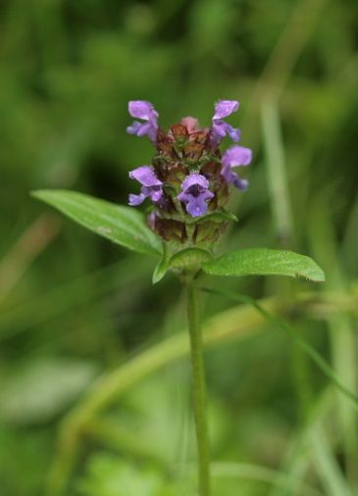  Self Heal
Bracken | Pteridium aquilinum
Bramble | Rubus fruticosa
Broad Buckler Fern | Dryopteris dilitata
Broad leaved Dock | Rumex obtusifolius
Broad Leaved Willow herb | Epilobium montanum
Bush Vetch | Vicia cassubica
Canadian Pond-weed | Elodea canadensis
Celandine | Ranunculus ficaria
Cock's Foot Grass | Dactylis glomerata
Comfrey | Symphytum officinale
Common Duck-weed | Lemna minor
Common Hemp-nettle | Galeopsis bifida
Common Ragwort | Senecio jacobaea
Cow Parsley | Anthriscus sylvestris
Creeping Buttercup | Ranunculus repens
Creeping thistle | Circium arvense
Crosswort | Cruciata laevipes
Daffodil | Narcissus pseudonarcissus |  | 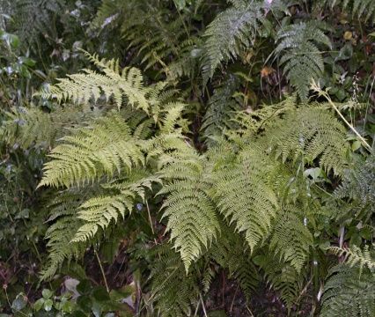  Broad Buckler Fern
Dog Rose | Rosa canina
Dog’s Mercury | Mucurialis perennis
Field Bindweed | Convolvulus arvensis
Figwort | Scrophularia nodosa
Forget-me-not | Myosotis arvensis
Foxglove | Digitalis purpurea
Garlic Mustard | Alliaria petiolata
Goose grass | Geum aparine
Greater Burdock | Arctium lappa
Greater Stitchwort | Stellaria holostea
Greater Willow herb | Epilobium hirsutum
Ground Elder | Aegopodium podagraria
Hard Rush | Juncus inflexus
Hart's Tongue Fern | Asplenium scolopendrium
Hedge Woundwort | Stachys sylvatica
Herb Bennett | Geum urbanum
Herb Robert | Geranium robertianum
Himalayan Balsam | Impatiens glandulifera
Hogweed | Heraclium sphondylium
Honeysuckle | Lonicera periclymenum |  | 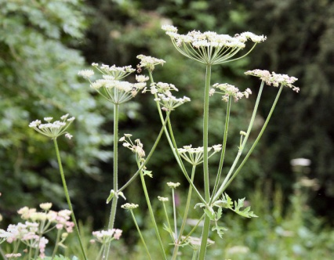  Hogweed
Ivy | Hedera helix
Japanese knotweed | Reynoutria japonica
Lords and Ladies | Arum maculatum
Male Fern | Dryopteris felis-mas*
Marsh Marigold | Caltha palustris
Meadow Crane’s-bill | Geranium pratense
Meadowsweet | Filipendula ulmaria
Nettle | Urtica dioica
Nipplewort | Lapsana communis
Primrose | Primula vulgaris
Purple Loosestrife | Lythrum salicaria
Ragged Robin | Lychnis flos-cuculi
Ramsons | Allium Ursinum
Raspberry | Rubus idaeus
Red Campion | Silene dioica |  | 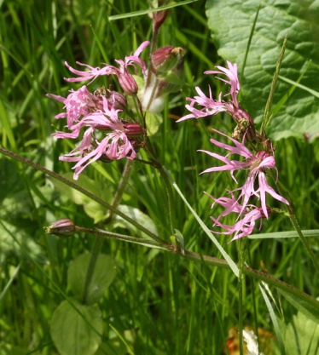  Ragged robin
Rosebay Willow herb | Epilobium angustifolium
Selfheal | Prunella vulgaris
Sweet Cicely | Myrrhis odorata
Teasel | Dypsacus fullonum
Water Avens | Geum rivale
Water Starwort | Callitiche stagnalis
White Dead Nettle | Lamium album
Winter Aconite | Eranthus hyemalis
Wood Anemone | Anemone nemorosa
Wood Sorrel | Oxalis acetosella
Woodrush | Luzula campestris
Yellow Flag | Iris pseudacorus
Yorkshire Fog | Holcus lanatus
Trees and Shrubs
Alder | Alnus glutinosa |  | 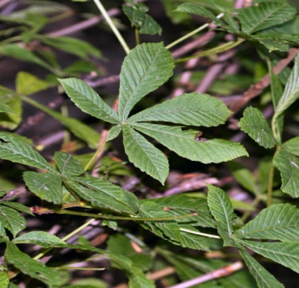
Ash | Fraxinus excelsior
Beech | Fagus sylvatica
Bird Cherry | Prunus padus
Crack Willow | Salix cracca
Elder | Sambuccus nigra
Elm | Ulmus sp.
Goat Willow | Salix capraea
Gooseberry | Ribes uva-crispa
Hawthorn | Crataegus monogyna |  | Horse Chestnut
Holly | Ilex aquifolium
Horse Chestnut | Aesculus hippocastanum
Mock Orange | Philadelphus sp.
Rhododendron | Rhododendron sp.
Rowan | Sorbus aucuparia
Sessile Oak | Quercus petraea
Sycamore | Acer pseudoplatanus
White Willow | Salix alba
Yew | Taxus baccata
Fungi
Bark Bonnet | Mycaena speirea
Candlesnuff Fungus | Xylaria hypoxylon
Coral Spot | Nectria cinnabarina |  | 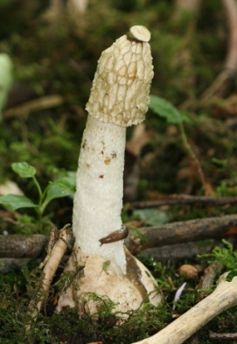
Common Puffball | Lycoperdon perlatum
Common Eyelash | Scutellinia scutellata
Dryad’s Saddle | Polyporus squamosus
Honey Fungus | Armillaria mellea
Jelly Ear | Auricularia auricula-judae
King Alfred's Cakes | Daldinia concentrica
Shaggy Scaly Cap | Pholiota squarrosa
Silky Rosegill** | Volvariella bombycina
Stink Horn | Phallus impudicus |  | Stink Horn
*On original list but not found
** 5th record for Co Durham

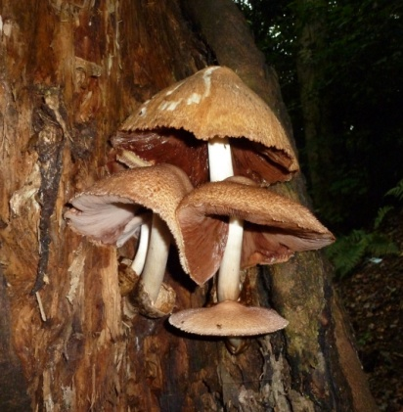
Silky Rosegill

Mammals

Hedgehog
Mole
Wood mouse
Brown rat
Short-tailed vole
Grey squirrel
Rabbit
Roe deer
Fox
Pipistrelle bat
Otter (In River)
Mink (In River)

Birds

Blackcap
Blackbird
Blue Tit
Brambling
Bullfinch
Carrion Crow
Chaffinch
Chiffchaff
Coal Tit
Collared Dove
Dunnock
Fieldfare
Goldcrest
Goldfinch
Garden Warbler
Great Spotted Woodpecker
Great Tit
Greenfinch
Green Woodpecker
Blackcap
Blackbird
Blue Tit
Brambling
Bullfinch
Carrion Crow
Chaffinch
Chiffchaff
Coal Tit
Collared Dove
Dunnock
Fieldfare
Goldcrest
Goldfinch
Garden Warbler
Great Spotted Woodpecker
Great Tit
Greenfinch
Green Woodpecker
Grey Wagtail
House Martin
House Sparrow
Jackdaw
Jay
Kestrel
Linnet
Long Tailed Tit
Magpie
Mallard
Mistle Thrush
Nuthatch
Pheasant
Pied Wagtail
Red Wing
Redpoll
Reed Bunting
Robin
Rook
Sand Martin
Siskin
Song Thrush
Sparrow Hawk
Starling
Swallow
Swift
Tawny Owl
Tree Creeper
Tree Sparrow
Whitethroat
Willow Warbler
Wood Pigeon
Wren
Yellow Hammer

Additionally on the River
Dipper
Grey Heron
Kingfisher Mallard
Mute Swan

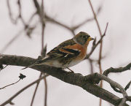
Invertebrates
INSECTS
Lepidoptera
Butterflies
Comma |  | Polygonia c-album
Meadow Brown |  | Maniola jurtina |  |  |  | 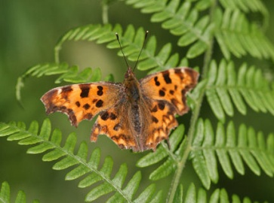  Comma
Orange tip |  | Anthocharis cardamines
Peacock |  | Inachis io
Red admiral |  | Vanessa atalanta
Ringlet |  | Aphantopus hyperantus
Small tortoiseshell |  | Aglais urticae
Small white |  | Pieris rapae
Large White |  | Pieris brassicae
Speckled Wood |  | Parage aegeria
Moths
Silver-ground Carpet |  | Xanthorhöe montanata
Common White Wave |  | Cabera pusaria
Diptera
Black-fly (larvae in stream) | Simulium sp.
Bluebottle | Calliphora vomitoria
Dolichopodid fly | Poecilobothrus nobilitatus |  |  |  | 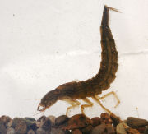  Dytiscus nymph
Flesh-fly | Sarcophaga carnaria
Greenbottle | Lucilia caesar
Hover-fly | Eupeodes nitens
Hover-fly | Volucella pellucens
Mosquito | Culex pipiens
Muscid fly | Phaeonia pallida
Muscid fly | Phaeonia pallida
Muscid fly | Phaeonia angelicae subventa
St Mark’s-fly | Bibio marci
Scorpion Flies
Scorpion Fly | Panorpa germanica
Dragonflies
Common Blue Damselfly | Enallagma cyathigerum
Large Red Damselfly | Pyrrhosoma nymphula |  |  |  | 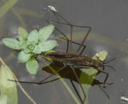  Pond skater
Southern Hawker | Aeschna cyanea
Hymenoptera
Bumble Bee | Bombus pratorum
Common Wasp | Vespa vulgaris
Solitary Bee | Andrena cineraria
Spiny Mason Wasp | Odynerus spinipes

Coleoptera
Great Diving Beetle (in pond) | Dytiscus marginalis
Whirligig Beetle (in pond) | Gyrinus natator
 |  | Helochares lividus
 |  | Hydrobius fuscipes(in pond)
Ladybird larvae
Hemiptera
Pond Skater | Gerris lacustris
Water Boatman | Corixa punctata
Mayflies |  |  |  |  |  |  | 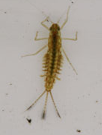  Mayfly nymph
Mayfly nymph (in pond) |  | Cloeon dipterum
Stoneflies
Stonefly nymph (in stream) |  | Leuctra??
Stonefly nymph (in stream) |  | Nemoura??
Crustacea
Water louse (in pond) |  | Asellus aquaticus
Water flea (in pond) |  | Daphnia pulex
Cyclops (in pond) |  | Cyclops sp
Mollusca
Great Pond Snail (in pond) |  | Limnea stagnalis
Jenkin's Spire Shell (in stream) |  | Potamopyrgus antipodarum |  |  |  |  | 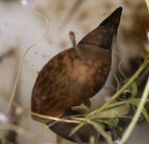  Limnea
Banded Snail |  | Cepaea hortensis
Banded Snail |  | Cepaea nemoralis
Trichia |  | Trichia hipida
Slug |  | Arion ater
Slug |  | Limax sp.
Platyhelminthes
Flatworm (in pond) |  | Polycelis nigra

Appendix B
5 Year Action Plan 2016 - 2020
Aims | Project description | Personnel | 2016 | 2017 | 2018 | 2019 | 2020
Conserving  Habitats | Thin sycamore | Contractor |  |  |  |  | *
 | Maintain woodland. Monitor newly planted trees. | FOWD | * | * | * | * | *
 | Strimming footpath verges | DCC/FOWD | * | * | * | * | *
 | Mow Meadows | DCC | * | * | * | * | *
 | Remove Balsam | FOWD/Volunteers | * | * | * | * | *
 | Clear Stream | FOWD | * | * | * | * | *
 | Clean/maintain Pond | FOWD | * | * | * | * | *
 | Maintain Newly Laid Hedges | DCC Rangers | * | * | * | * | *
 | Strimming Verges | DCC/FOWD
Conserving species | Survey nest and owl boxes | FOWD/Contractors |  | * |  | *
 | Erect more bird boxes as necessary | FOWD/Contractors
 | Maintain existing and create new ground hibernation sites. | FOWD/Men’s Shed | * | * | * | * | *
Public enjoyment | Improve and maintain Footpaths and access. | Men’s Shed | * | * | * | * | *
 | Maintain Interpretation Boards | FOWD | * | * | * | * | *
 | Improve signage at Access Points to Dene | FOWD | *
 | Maintain safety of public by regular site inspection | FOWD/DCC | * | * | * | * | *
 | Enforce Dog Fouling Programme—erect warning notices. | FOWD | * | * | * | * | *
Admin and publicity | Record and archive | FOWD | * | * | * | * | *
 | Prepare leaflets/notifications | FOWD | * | * | * | * | *

Record of Work undertaken/completed
TASK | DATES COMPLETED AND BY WHOM | DATES COMPLETED AND BY WHOM | DATES COMPLETED AND BY WHOM | DATES COMPLETED AND BY WHOM | DATES COMPLETED AND BY WHOM
HYMALAYAN BALSAM BASHING
LOWER PATH MAINTENANCE/IMPROVE
UPPER PATH MAINTENANCE/IMPROVE
NORTH MEADOW MOWN/MAINTAIN
SOUTH MEADOW
MOWN /MAINTAIN
PATH VERGES STRIMMED
YOUNG TREES INSPECTED/MAINTAINED
LITTER PICKING

CLEAN INTERPRETATION BOARDS
MAINTAIN/ERECT BIRD/OWL BOXES
CLEAN POND/AREA

MAINTAIN HEDGES

CLEAR STREAM

THIN SYCAMORE AND DISEASED/DANGEROUS TREES

