Background paper on Heritage

Vision
Witton Gilbert village is pleasantly situated on a south facing slope down to the river Browney. The parish is mainly rural in nature and the extensive surrounding countryside with its many accessible footpaths and bridleways provides an attractive and healthy residential and working environment. The Dene burn with Witton Dene nature reserve enhances this character. The village has a long history with much evidence of prehistoric and medieval settlements and, more recently, of agricultural and mining communities. The newly completed village centre development has been designed to provide a symbolic representation of this past. The oldest part of the village lies along the northern boundary of the medieval enclosed park of the Priors of Durham; the western limit lies within the parish at Wall Nook. Despite considerable growth during the last hundred years the remaining nucleus of the original village retains many recognisable features of its earlier history. This designated “heritage zone” and, within it, the Front Street in particular, gives context to the present village and we feel that any future developments should ensure that this heritage is safeguarded and enhanced to preserve the distinctive nature of the village and the surrounding area. More than 75% of respondents to the Parish Plan survey identified the protection of the historic features of the village as important and that they should be made integral to any future planning strategy for the village.
Issues
Outside the main residential area which is the village of Witton Gilbert, the parish consists of small hamlets at Kimblesworth Grange, and Wallnook, some isolated farms and residential properties such as Sniperly Hall and Findon Mews. Many of the farms and dispersed properties are built of local stone and are of historic interest, retaining buildings or features that date from the seventeenth century or earlier. Despite later developments, the earliest part of the village on Coach Lane preserves its character with the parish church built around 1170, and Witton Hall farm retaining masonry and buildings from a hospital of the same period. Coach Lane is bounded to the East by Witton Dene which is a managed nature reserve serving as a considerable local recreational and educational asset, and a much used farm track and footpath leading down to the river.

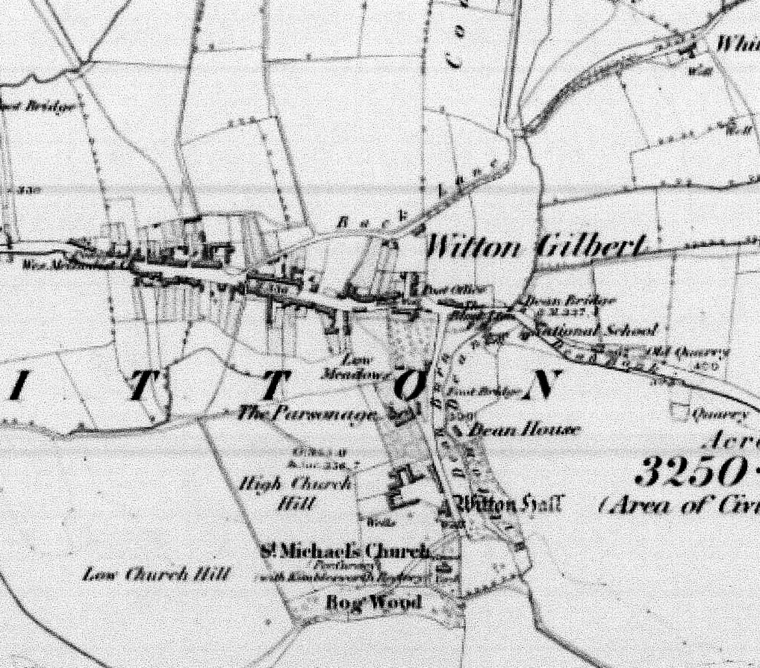
Witton Gilbert 1857
Brick terrace homes adjacent to the Front Street were constructed in the nineteenth century to house working families who worked in nearby village collieries and the Consett iron works, using the railway which is now a popular footpath and cycling track. Witton Gilbert has itself little mining heritage. Many of the houses built in 19th and 20th centuries are in styles and materials found all over England and tend to emphasise Front Street and surrounding farms as the local historic heritage. Elsewhere, older buildings add to the diversity and appearance of the village.

Although major housing developments have taken place to the north of the village, the construction of a bypass in 1997 has removed much of the traffic from Front Street, helping to restore the character of the old village where the housing scene has remained relatively unchanged. There is only one listed building on Front Street and, although the other buildings are individually of little architectural significance, they do offer a recognizable glimpse of the past and collectively provide an attractive streetscape. Many owners have made sympathetic upgrading to their houses and we would like to ensure that any further infill or developments made a corresponding contribution to this area to maintain the character of the area.

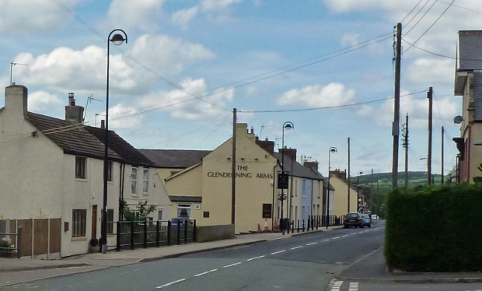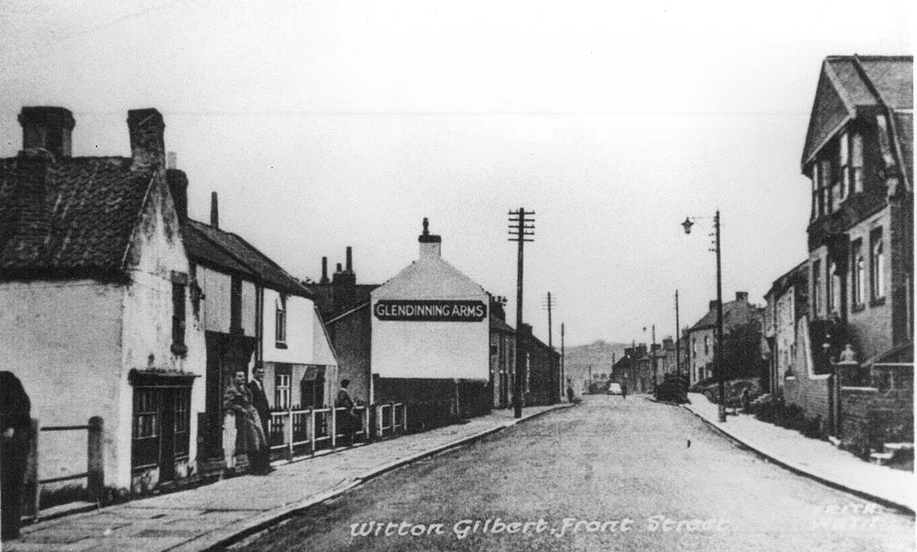
Front Street : 2017 (left) circa 1900 (right)

Coach Lane has been included within the historic core for the sake of completeness and because the majority of statutory listings lie in this area.

Legal Framework
Many buildings and several other features are listed and so legally protected. All Future developments in the village and outlying area should comply with local and national heritage policies.

Scheduled Buildings and Monuments
The current nationally listed buildings and scheduled monuments found in the parish comprise:
- Witton Hall and Wall Attached Grade II*
- Barn at Witton Hall Farm Grade II
- Church of St Michael and All Angels Grade II
    - Clark Tomb Grade II
    - Hopper Tomb Grade II
    - Jobling and Hogen Tombs Grade II
    - Pickeran Tomb Circa Grade II
    - Snaith Tomb Circa Grade II
- Former Smithy to West of No 29 Grade II
- Fyndoune and Fyndoune Mews Grade II
- Well House Fyndoune Mews Grade II
- Kaysburn House Grade II
- Kimblesworth Grange Farmhouse with Wall and Outhouse Attached Grade II
Other buildings and sites that add to the character and distinctiveness of the parish and are worthy of protection include:

- Front Street (including historic building line)
- Glendenning Arms
- Traveller’s Rest
- War memorial
- Witton station

Aims
Any developments should endeavour to maintain the character of the village and planning policies must be adopted to protect the identified heritage sites within the parish and where possible improve access and make information about these heritage assets available to residents and visitors. It would be desirable to enhance the area by removing the many telephone and other posts which detract from the street scene.

Policy
- A number of non scheduled buildings and sites noted for their heritage value should be protected
- Scheduled monuments and listed buildings must be protected and maintained for their distinctiveness and for their contribution to the historic identity of the parish
- Developments must not detract from designated or historic non-designated sites and the approaches to them.
- All future developments must be considered in the light of the local and national heritage policies.

